KATHMANDU UNIVERSITY
Department of Computer Science and Engineering
Dhulikhel, Kavre

A Project Report
On
“KU InfoBot: A Rule-Based Chatbot for KU”
[Code No.: ENGG 102]
(For partial fulfillment of Year I / Semester II in Computer Engineering)

Submitted by:
Smriti Niroula (Roll No: 17)
Prayag Parajuli (Roll No: 30)
Aislinn Paudel (Roll No: 32)
Ajesh Pokhrel (Roll No: 40)
Prashis Prasai (Roll No: 45)

Submitted to:
Suman Shrestha
Department of Computer Science and Engineering
April 27, 2026

Abstract

Chatbot systems are increasingly used in educational institutions to provide quick and automated responses to user queries. However, accessing organized and accurate university information remains challenging for students, as the required information is often scattered across multiple websites, notices, and departmental resources. This project presents KU InfoBot, a rule-based desktop chatbot developed to provide structured information related to Kathmandu University, including academic programs, admission procedures, fee structures, examination routines, and frequently asked questions.
The system was implemented using the C++ programming language and the Qt framework by following the principles of Object-Oriented Programming (OOP). It adopts a rule-based approach to process user queries through typo correction, synonym mapping, and intent recognition before retrieving relevant information from dedicated knowledge modules. A web crawler was also integrated as a fallback mechanism to retrieve information when it was unavailable in the local knowledge base.
The developed chatbot provides a simple and user-friendly interface capable of responding efficiently to predefined university-related queries. It improves access to university information while reducing the time required for manual searching. Overall, the project demonstrates the practical application of fundamental software engineering concepts in developing an educational information system and provides a foundation for future enhancements, such as multilingual support and AI-assisted query processing.
Keywords: Chatbot, Rule-Based System, Information Retrieval, C++, Qt Framework, Object-Oriented Programming, Intent Recognition

Contents

Abstract i
List of Figures iii
Abbreviations iv
Chapter 1: Introduction 1
1.1 Background 1
1.2 Objectives 2
1.3 Motivation and Significance 2
1.4 Expected Outcomes 3
Chapter 2: Related Works 4
Chapter 3: Procedure and Methods 5
Chapter 4: System Requirement Specifications 7
4.1 Software Specifications 7
4.2 Hardware Specifications 8
Chapter 5: Project Planning and Scheduling 9
5.1 Tasks 10
References 11

List of Figures

Figure 3.1: Flowchart of InfoBot Architecture…………………………………….6 Figure 4.1: Use-Case Diagram of KU InfoBot…………………………………….7 Figure 5.1: Gantt Chart of Project Schedule……………………………………….9

Abbreviations

AI: Artificial Intelligence
GCC: GNU Compiler Collection
IBM: International Business Machine
I/O: Input/Output
NLP: Natural Language Processing
OOP: Object Oriented Programming

Chapter 1: Introduction

This chapter introduces KU InfoBot, a rule-based desktop chatbot developed to simplify access to information related to Kathmandu University. It discusses the background of the project, the objectives achieved during its development, and the motivation behind selecting the topic. The chapter also highlights the significance of the system and explains how it addresses the challenges of accessing university information through a centralized and user-friendly platform.

1.1 Background
Educational institutions generate and update a large amount of information every academic year. Students frequently need details about admissions, academic programs, fee structures, examination schedules, class routines, scholarships, and various university services. Although this information is available through official university websites, departmental portals, and notices, finding specific information is not always straightforward. Students often have to search through multiple webpages and documents before locating the information they need. This process can be time-consuming, particularly for prospective students and first-year students who are unfamiliar with the university's organizational structure.
With the increasing use of digital technologies, chatbots have become a popular solution for providing instant access to information. Many organizations now use chatbot systems to answer frequently asked questions, reduce manual workload, and improve user experience. Educational institutions have also started adopting chatbots to assist students with common academic and administrative queries. Most modern chatbot systems rely on Artificial Intelligence (AI) and Natural Language Processing (NLP), allowing them to understand different forms of user input and generate conversational responses. While these systems are highly capable, they require large training datasets, greater computational resources, and more complex implementation techniques.
For applications where the available information is structured and the expected queries are relatively predictable, a rule-based chatbot offers a practical alternative. Instead of learning from data, it retrieves information using predefined rules and organized knowledge. This approach makes the system easier to develop, maintain, and update while providing reliable responses within a specific domain. Since university-related information generally follows a well-defined structure, a rule-based approach is well suited for this application.
Based on these observations, KU InfoBot was developed as a desktop-based chatbot specifically for Kathmandu University. The system allows users to obtain information related to admissions, academic programs, fee structures, examination routines, and frequently asked questions through a single interactive interface. To improve the quality of responses, the chatbot processes user queries through typo correction, synonym mapping, and intent recognition before retrieving information from dedicated knowledge modules. If the requested information is unavailable in the local knowledge base, a web crawler is used as a fallback mechanism to search for relevant information online.

1.2 Objectives
The main objectives achieved during this project are as follows:
- To design and develop a rule-based desktop chatbot for Kathmandu University using C++ and the Qt framework.
- To provide structured information related to admissions, academic programs, fee structures, examination routines, and frequently asked questions through a centralized system.
- To improve the accuracy of user queries by implementing typo correction, synonym mapping, and rule-based intent recognition.
- To develop a modular and maintainable software architecture with a web crawler as a fallback mechanism for retrieving unavailable information.

1.3 Motivation and Significance
Students often spend considerable time searching through different university webpages and notices to find simple information. Although the required information is publicly available, it is distributed across multiple sources, making the search process inconvenient and sometimes confusing. This problem motivated the development of KU InfoBot, with the goal of providing a single platform through which users can quickly access university-related information.
Unlike many existing university chatbots that rely on Artificial Intelligence and require extensive training data, KU InfoBot follows a rule-based approach that is lightweight, reliable, and easier to maintain. The project demonstrates that a well-organized knowledge base, combined with typo correction, synonym mapping, and intent recognition, can provide accurate responses without the complexity of machine learning models. This makes the system suitable for structured information retrieval while remaining easy to extend and update.
From an academic perspective, the project provided practical experience in applying Object-Oriented Programming, modular software design, file handling, string processing, and graphical user interface development using C++ and the Qt framework. The modular architecture also allows future enhancements, such as database integration, multilingual support, and AI-assisted query processing, to be incorporated without major changes to the existing system.
The implemented system successfully integrates multiple components into a single application capable of processing user queries and retrieving relevant university information efficiently. Key features of KU InfoBot include a graphical user interface, typo correction, synonym mapping, intent recognition, dedicated information modules, and a web crawler fallback mechanism. Together, these features provide a centralized, user-friendly, and maintainable solution for accessing Kathmandu University information.

1.4 Scope of the Project
The scope of this project is limited to developing a rule-based desktop chatbot that provides information related to Kathmandu University. The system focuses on retrieving structured information efficiently through a simple and user-friendly interface. The major scope of the project includes:
- University Information Retrieval: Provides information related to admissions, academic programs, fee structures, examination routines, class schedules, and frequently asked questions.
- Rule-Based Query Processing: Processes user queries using a rule-based approach without relying on Artificial Intelligence or Machine Learning models.
- Input Preprocessing: Improves query understanding through typo correction, synonym mapping, and intent recognition before retrieving responses.
- Graphical User Interface (GUI): Offers an interactive desktop interface developed using the Qt framework, allowing users to communicate with the chatbot conveniently.
- Web Crawler Fallback: Retrieves relevant information from online sources when the requested information is unavailable in the local knowledge base.
- Modular Architecture: Organizes different functionalities into independent modules, making the system easier to maintain, update, and extend.

1.5 Expected Outcomes
The outcome of this project is KU InfoBot, a functional desktop-based chatbot that provides structured information related to Kathmandu University through a centralized interface. The system successfully processes user queries using typo correction, synonym mapping, and intent recognition before retrieving information from dedicated knowledge modules. It also incorporates a web crawler as a fallback mechanism when the requested information is unavailable in the local knowledge base. The developed chatbot provides quick and reliable responses to common university-related queries, reducing the time required to search through multiple websites and documents. Overall, the project demonstrates the practical application of C++, the Qt framework, Object-Oriented Programming, and modular software design in developing an efficient university information system while providing a strong foundation for future enhancements.

Chapter 2: Related Works
This chapter reviews existing studies and chatbot systems related to educational information retrieval. It discusses different approaches used in chatbot development, including rule-based and Artificial Intelligence (AI)-based systems, and compares their strengths and limitations. The chapter also highlights the gap addressed by KU InfoBot and explains how the developed system differs from existing solutions.

Chatbots have been widely adopted in educational institutions to automate information delivery and improve accessibility. International Business Machine (IBM) defines chatbots as systems that simulate human conversation to provide automated assistance, while GeeksforGeeks distinguishes between rule-based and AI-driven approaches. Rule-based systems are predictable and simple, whereas AIbased systems offer flexibility but require complex algorithms and large datasets.

In Nepal, practical implementations of educational chatbots have already been demonstrated. For example, Sigdel, Shrestha, and Neupane (2024) developed a College Chatbot Using RASA at Kathmandu Engineering College, which utilized NLP and machine learning to answer student queries with high accuracy. Similarly, Nepal’s Conversational AI Research Agenda (2025) emphasizes the importance of chatbots in education, highlighting challenges in low-resource languages like
Nepali and proposing frameworks such as NepBERTa to improve performance.

Compared to these systems, the proposed project uses a rule-based chatbot developed in C and C++, focusing on simplicity and ease of implementation. The system includes typo correction, synonym handling, and basic intent recognition to improve input processing. It provides structured and accurate information about Kathmandu University. Although limited in handling complex queries, it effectively delivers reliable and user-friendly information retrieval.

Chapter 3: Procedure and Methods

Initially, data collection will be performed to gather relevant information about Kathmandu University. This includes details such as courses offered, admission procedures, fee structures, available facilities etc. The collected information will be obtained from reliable sources such as the official university website and related documents. After collection, the data will undergo a digitization process, where the information will be organized and converted into a structured format suitable for implementation within the chatbot system.

Following this, requirement analysis will be conducted to determine the specific functionalities of the chatbot based on the collected data. Based on these requirements, the system design will be developed, including the interaction flow between the user and the chatbot.

The implementation phase will involve coding the chatbot using C and C++ programming language. Basic programming constructs such as loops, conditional statements, and string handling will be used to process user input and generate appropriate responses. A rule-based approach will be implemented where specific keywords are matched with predefined outputs.

Finally, testing and debugging will be carried out to ensure that the chatbot responds accurately to various user inputs. The system will then be refined and properly documented for final submission.

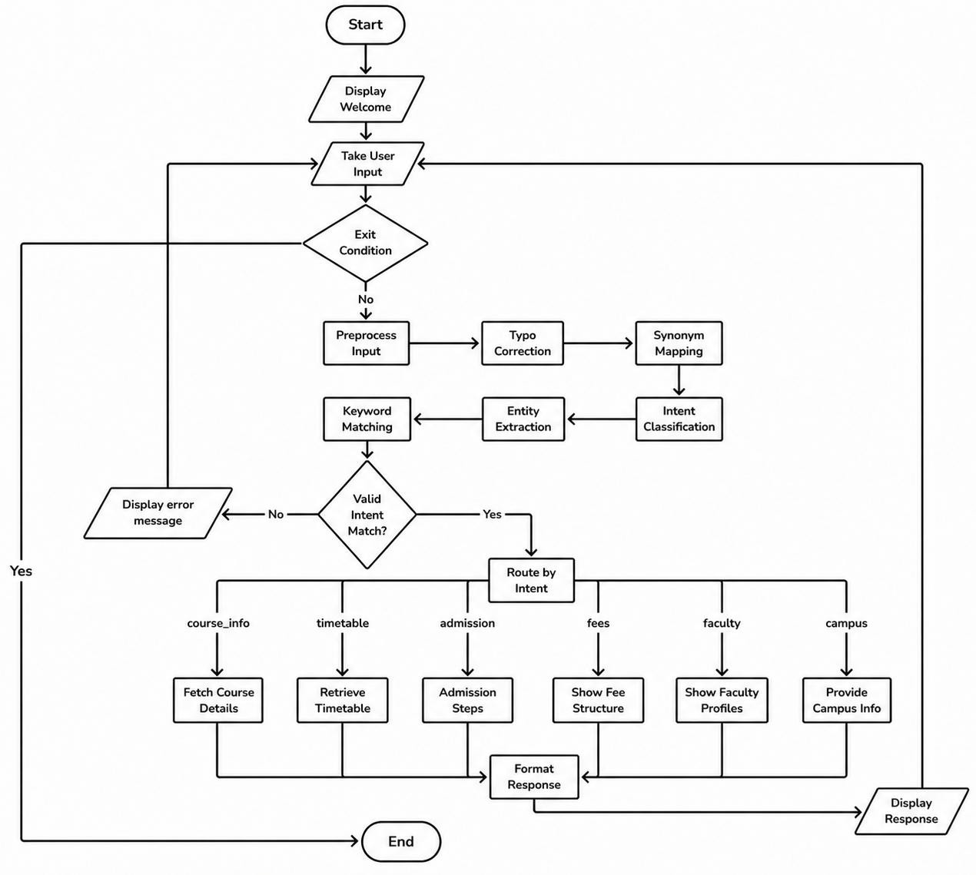

Figure 3.1: Flowchart of InfoBot Architecture

Chapter 4: System Requirement Specifications

In order to build and operate the KU InfoBot, the project requires a set of defined hardware and software specifications. These specifications serve as the foundation for ensuring smooth functionality, reliable performance, and effective interaction between the user and the system.

4.1 Software Specifications

- Programming Language: C/C++
- Compiler: GCC (GNU Compiler Collection)
- Framework and Libraries: Qt, Standard C/C++ libraries
- Development Tools: Visual Studio Code, Git, Github
- Operating System: Windows / Linux / MacOS
- Build System: CMake

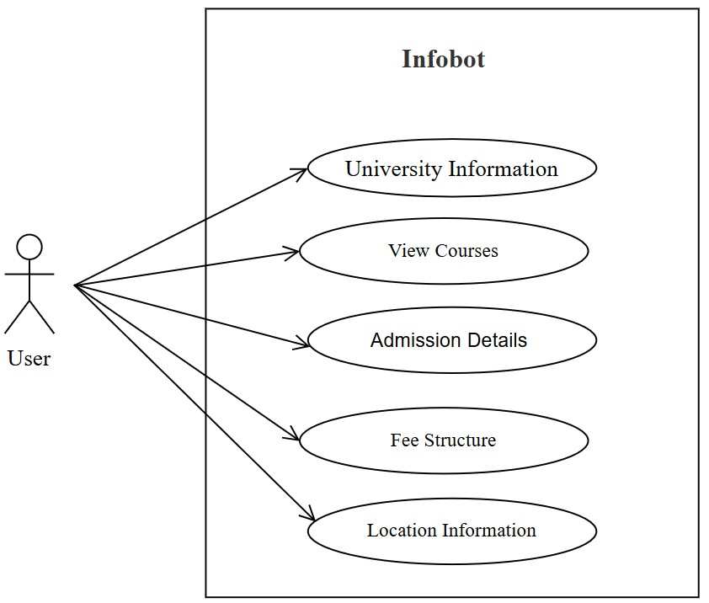

Figure 4.1: Use-Case Diagram of KU

4.2 Hardware Specifications

The hardware requirements for the system are minimal. The chatbot can run on any basic computer system with the following configuration:

- Processor: Intel i3 or above • RAM: 2 GB or more
- Stable internet connectivity
- I/O Devices: Keyboard and monitor

Chapter 5: Project Planning and Scheduling

To carry out the KU InfoBot project in an organized and timely manner, a clear plan and schedule are essential. Proper structuring of tasks, allocation of time, and systematic tracking of progress ensure that each stage of development is completed efficiently. By outlining the sequence of activities from problem identification and requirement gathering to final submission, the project establishes a roadmap that guides the team toward successful completion.

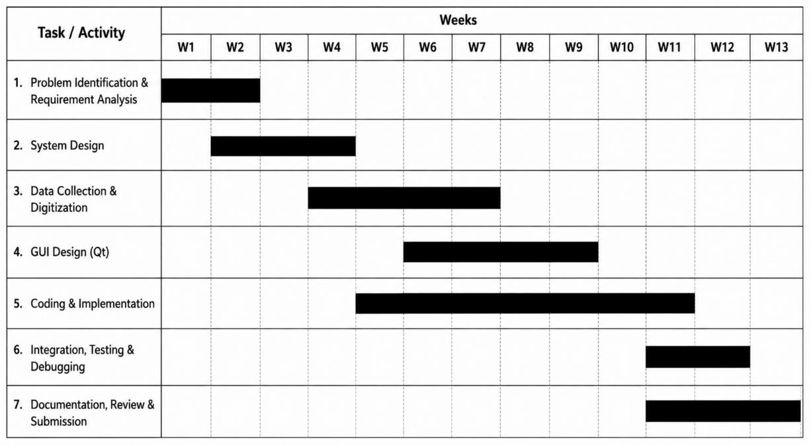
Figure 5.1: Gantt Chart of Project Schedule
The project will begin with problem identification and requirement gathering, followed by system design and data collection along with digitization. The coding and implementation phase will take the longest duration, followed by testing, documentation, review, and final submission.

5.1 Tasks

The major tasks involved in the project are:

- Problem Identification and Requirement Analysis
- Data Collection and Digitization
- System Design
- GUI Design using Qt Framework
- Coding and Implementation using C/C++
- Integration, Testing, and Debugging
- Documentation, Final Review and Submission

References

GeeksforGeeks. (n.d.). Chatbot Theory Explained! Retrieved from
GeeksforGeeks: https://www.geeksforgeeks.org/blogs/chatbot-theory-explained/
IBM. (n.d.). Chatbots. Retrieved from IBM:
https://www.ibm.com/think/topics/chatbots
Sigdel, Y., Shrestha, S., & Neupane, N. (2024). College chatbot using RASA.
KEC Journal of Science and Engineering, 8(1), 38-43.
doi:https://doi.org/10.3126/kjse.v8i1.69263

